Pricing Performance Tuning Report
For Argus Health
By Hengtian Software Ltd.
11/22/2013

Revision History
Version | Comment | Revised By | Approved By | Date
1.0 | Draft | JidanYin |  | 12/1/2013

Table of Contents
1. Executive Summary 4
2. Testing Methodology & Result 5
2.1 Concurrency Bottleneck Testing 6
2.1.1 Testing Strategy 6
2.1.2 Testing Goal 6
2.1.2 Testing Result 6
2.1.2 Conclusion & Tuning Tips 6

1. Executive Summary

The performance testing for Pricing application started from 2013-09-23 to 2013-11-23. This testing aims to evaluate the performance of Argus Pricing application as well as help Argus team to find potential performance related bottlenecks, bugs and errors. We applied JMeter to execute test cases in heuristic way to evaluate response time and throughput of key scenarios. JMeter’s Summary Report was applied to record the Max Response time, Average Response Time, Min Response. The performance testing efforts thoroughly reveal the quality of Argus Pricing Application to reduce the potential risks before production.
The following subsections will briefly describe the important test scenarios, including test strategy, test goal, test result, monitor data and conclusion. We draw conclusions with the analysis based on test data, monitoring data, profiling and tuning.

2. Testing Methodology & Result
Based on our application, we separate our testing strategy into different categories. Each categories has different testing goals and different output.

2.1 Concurrency Bottleneck Testing

2.1.1 Testing Strategy
In thread group, set users for different values separately, set ramp up sufficient time for every user to complete login process(we do not want to test login process concurrency bottleneck). And set Loop for small times. For each test plan, execute for more times to improve accuracy. Set case including all operation with certain possibility to test general performance of the system.

Example: in case web container pool size=100, We simulate 1Vus, 20Vus, 50Vus, 100Vus and 200Vus to visit Argus system separately. All threads will start in 5 second(do not set like this, it is too small, in test result, we found concurrency pressure happened on login process). Each virtual user should execute the test 1 time. The think time between each action is 0.3 second. And we just test performance of Pricing Options Search function in this case for POC period (BS: run all operation needs more than 1 PC).
users=1,loop=1
users=20,loop=1
users=50,loop=1
users=100,loop=1
users=200,loop=1

2.1.2 Testing Goal
The thread group simulates different users to execute a particular test case against your server. It aims to our system performance under different concurrency. The test is used to test bottleneck at high concurrency, including: CPU pressure, memory pressure, EJB/WEB thread pool pressure, DB2 connection pool pressure.

2.1.3 Testing Result
Refer to below path for detail: http://172.16.5.12/svn/argus/common/Architect/Architecture Action List/5. Performance Tuning/Jmeter/2685-performence test/performence test result
1. Average Time
Date | Case | Users | Web Pool Size | Loop | ramp-up | JMeter Location | Average time
 |  |  |  |  | (second) | JMeter Location | (s)
11/14/2013 | Princing Option - View | 1 | 100 | 1 | 0 | Local/ZDEV | 2.7
11/14/2013 | Princing Option - View | 20 | 100 | 1 | 5 | Local/ZDEV | 17
11/4/2013 | Princing Option - View | 50 | 100 | 1 | 5 | Local/ZDEV | 20
11/4/2013 | Princing Option - View | 100 | 100 | 1 | 5 | Local/ZDEV | 74
11/4/2013 | Princing Option - View | 200 | 100 | 1 | 5 | Local/ZDEV | 180

2. Testing Symptom Web Server
Below system status are monitored:
- thread pool usage
- JVM heap usage,
- memory
- Zdev

- Webspehre PMI

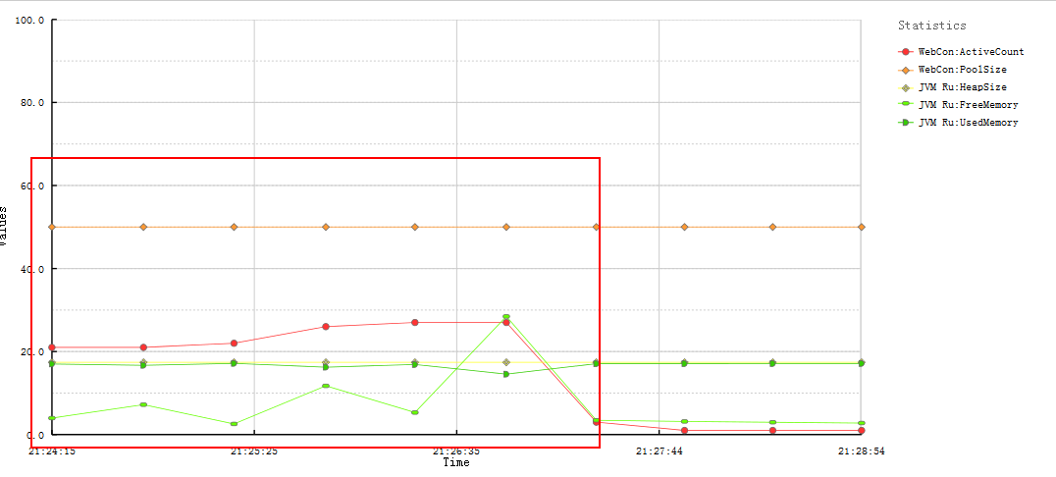
- User=20

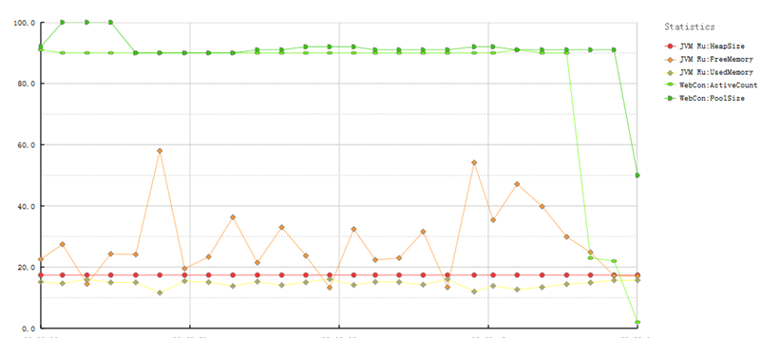
- User=100

In Graph a), user = 20, during test running active threads are almost 20~24. , it means most of the threads in pool are not busy. When JVM used memory near JVM heap size, some memory is freed. No memory problem is found.
In Graph b), user = 100, during test running active threads are almost 90~100, it means most of the threads are busy. When JVM used memory near JVM heap size, some memory is freed. No memory problem is found.

- Vmstat

vmstat 1 1000 | (while read -r line; do echo "$(date +'%Y-%m-%d %H:%M:%S'): $line"; done) > /usr/IBM/WebSphere/AppServer/profiles/AppSrv/jvm-agents/systemPerformenceDuringTest.txt

Input above command in putty, system status is observed once 1 second for 1000 times and will be logged in file systemPerformenceDuringTest.txt.
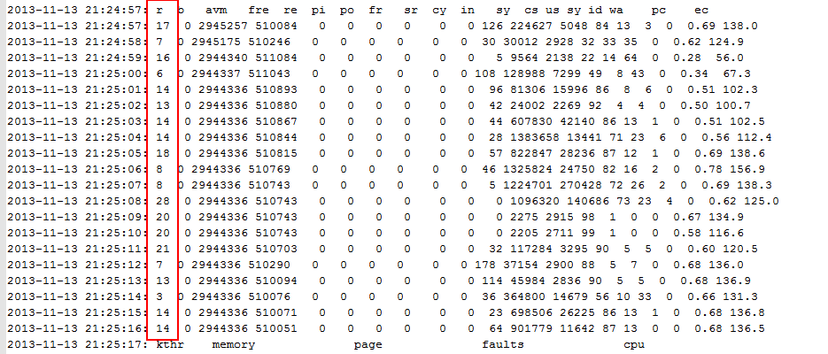
(c) Users=20, during test
In gragh c), users=20, r value < 20, most of the time, CPU has no pressure. pi/po is always 0，no page in/ page out happened, it means no memory pressure.
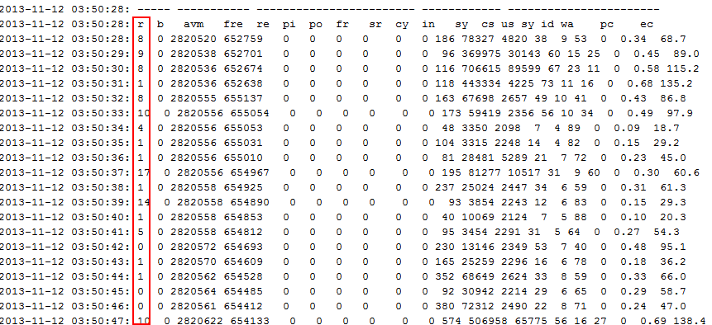
(d) Users=100, at begining
In gragh d) at the beginning, r value is very small(<<20), it means no CPU pressure.
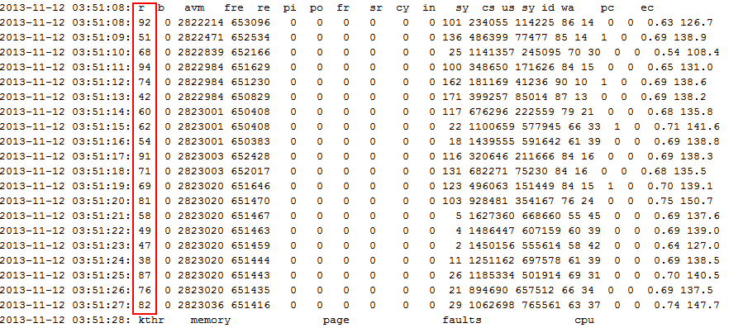
(e) Users=100, during test

In graghe e) During the test，r value grows very big (>>20) and remains for a long time, it means CPU pressure happends. pi/po is always 0，no page in/ page out happened, it means no memory pressue. During this time, Zdev responses very slow. After completed test for 10 minutes, Zdev responses back to normal. And in some test, Zdev die of too slow. But after stop the test, we found Zdev responses back to normal too.

3. Testing Symptom EJB Server
Below status are on monitor:
- Object Remote Broker thread pool usage
- JVM heap usage
- Memory usage
- DB Connection pool usage

- WebSphere PMI

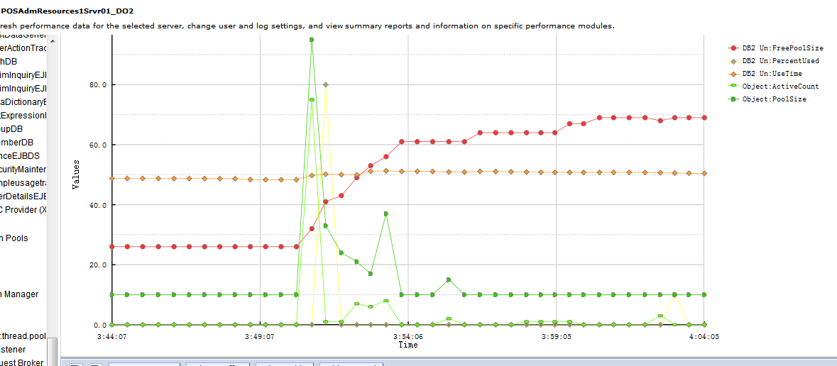
f) users=100
In gragh f), EJB ORB active count impulses at the beginning, almost 95 EJB remote calls happen, and then rapily decline and remain stable about 10. It means very few EJB remote call happens at most of the time. Percentage use of DB2 connection pool is very slow too. We can see, in this case, EJB site and DB2 connection do not have pressure.
- Vmstat

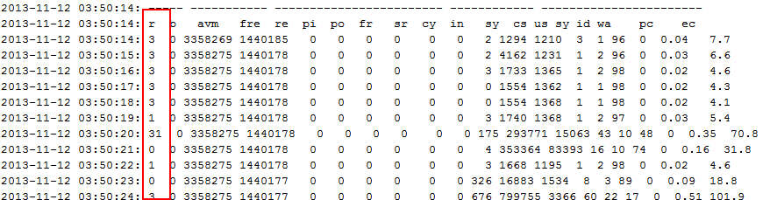
(g) users=100, before test

In gragh g), r value is very small. ORB pool size=10，ORB active count=0, No EJB remote call happens. DB2 free pool size=25, DB2 percentageUsed=0, no DB2 operation.

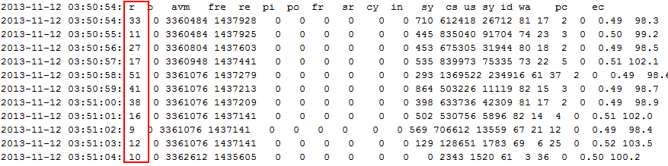
(h) users=100, at beginnig
In gragh h) at the beginning, ORB active count迅速出现峰值，此阶段ORB pool size=100, ORB active count=75, 说明EJB端线程池增加至100，EJB被调用，活跃的线程有75个，此时DB2 percentageUsed=80，说明有数据库操作。DB2 free pool size=40,说明连接池仍然有剩余

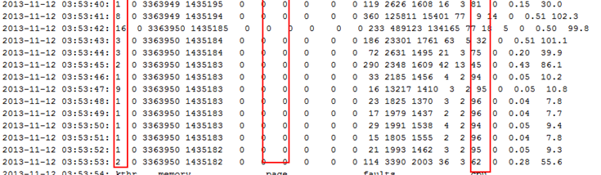
(i) users=100, during test
In gragh i) after 2 minutes of test started：DB2 percentageUsed=0, ORB active count=7，之后长时间接近于0，偶尔DB2 percentageUsed=10, ORB active count=4，说明EJB操作频率非常低， DB2操作频率更低，这和监测到EJB 端CPU压力下降的现象是相符的。

2.1.4 Conclusion & Tuning Tips
Search function in the system does not perform well when the virtual user is more than 20.
To test general performance of the system, set case including all operation with certain possibility.
For case users=100, loop=1:
Web server starts without pressure. At a time point, Web server start having pressure, and r value keep increase which means more and more thread are waiting for CPU, CPU usage almost reach 90%. Time cost to handle the request increased.But system not die. Memory usage is in normal level.
EJB server has pressure at the beginning. EJB server pressure decrease since Web server get bottleneck.

2.2 Memory leak Testing

2.2.1 Testing Strategy
Set users for appropriate value (not too high concurrency to effect system performance), Set loop for much more times, and set case including all operation with certain possibility. Execute for more times to reduce errors and improve accuracy.
Example: Loop>1000

2.2.2 Testing Goal
Travel main application scenarios to find out any possibility to cause memory leak.

2.2.3 Testing Result
Refer to below path for detail: http://172.16.5.12/svn/argus/common/Architect/Architecture Action List/5. Performance Tuning/Jmeter/2685-performence test/performence test result
1. Average Time
Date | Case | Users | Web Pool Size | Loop | ramp-up  (second) | JMeter Location | Average time  (s)
11/15/2013 | All operation | 14 | 100 | 1000 | 200 | Local/ZDEV | 7
10/29/2013 | All operation | 7 | 50 | 100 | 0 | Local/ZDEV | 2.4
11/16/2013 | All operation | 15 | 100 | 10000 | 500 | Local/ZDEV | 1.62
11/18/2013 | all operation | 50 | 100 | 5000 | 500 | Local/ZDEV | n/a
11/19/2013 | All operation | 50 | 100 | 5000 | 500 | Local/ZDEV | 5

In case 11/19/2013, test run for 6 hours on 4 PC. But Jmeter kills one thread every half hour at every PC. It causes average time declines as time going on.
In case 11/18/2013, zdev die of too slow. But after stop the test, we found Zdev responses back to normal too. The same conclution has been got from before test too. So we can say, no memory leak happends.

2. Testing Symptom Web Server
Monitor below status, we found Web server pressure do not rise as time going on, and memory usage is in normal level. So the application do not have memory link problem.
- thread pool usage
- JVM heap usage
- memory
- Zdev

3. Testing Symptom EJB Server
Monitor below status, EJB server has no pressure
- Object Remote Broker thread pool usage
- JVM heap usage
- Memory usage
- DB Connection pool usage

2.2.4 Conclusion & Tuning Tips

Pricing application do not have memory leak problem.

2.3 System general performence Testing

2.3.1 Testing Strategy
Set case including all operation with certain possibility. Refer to “chapter 4 workload Characterization” for detail.

2.3.2 Testing Goal

Test general performance of the application.

2.3.3 Testing Result
1. Average Time

2. Testing Symptom Web Server

3. Testing Symptom EJB Server

2.3.4 Conclusion & Tuning Tips

2.4 Function performance testing

2.4.1 Testing Strategy
Set case including certain operation, such as search, update, delete, mass change.

2.4.2 Testing Goal
Test the performance for one operation. It focuses on special operation or slow step. It has two case need this test:
1) Main operation scenarios in the system: test average response time, after most of main operations has been tested, the most slowest operation and steps are found. It is one direction to tune our application.
2) Some operation scenarios might has special requirement, such as have much more entries, or have much more date ranges, … this test is one method to find the slow operations or steps.

2.4.3 Testing Result
1. Average Time
Each operation average time = 2~3s
Refer to below path for detail average time: http://172.16.5.12/svn/argus/common/Architect/Architecture Action List/5. Performance Tuning/Jmeter/2685-performence test/performence test result/20131121-user=2,loop=10,case=each operation/Frame
2. Testing Symptom Web Server
No pressure

3. Testing Symptom EJB Server
No pressure

2.4.4 Conclusion & Tuning Tips

2.5 Real performance as production environment

2.5.1 Testing Strategy

Set users 10 times as real user number on product environment, and loop for 10 times as real too.

2.5.2 Testing Goal
Test system performance on real production environment.

2.5.3 Testing Result
1. Average Time
2~3s
http://172.16.5.12/svn/argus/common/Architect/Architecture Action List/5. Performance Tuning/Jmeter/2685-performence test/performence test result/20131121-user=2,loop=10,case=each operation/Frame
2. Testing Symptom Web Server
No pressure

3. Testing Symptom EJB Server
No pressure

2.5.4 Conclusion & Tuning Tips
Pricing application does not have performance issue on production environment.

2.6 System performance except Network transmission

2.6.1 Testing Strategy

Run JMeter on application web server deployed host, in this case DO2-pricing web site is deploy on 232 host.

2.6.2 Testing Goal
Test system performance on real production environment.

2.6.3 Testing Result
1. Average Time
Date | Case | Users | Web Pool Size | Loop | ramp-up  (second) | JMeter Location | Average time  (s)
12/10/2013 | View Pricing option | 1 | 100 | 10 | 0 | Local/ZDEV | 3.4
12/10/2013 | View Pricing option | 1 | 100 | 10 | 0 | ZDEV/ZDEV | 1.4
Iperf
jperf
- Testing Symptom Web Server

3. Testing Symptom EJB Server

2.6.4 Conclusion & Tuning Tips
Net transfer spends more than half time in one response. Real production will not have too much net transfer, it will performance better than from HT side.

2.7 System throughout testing

2.7.1 Testing Strategy

2.7.2 Testing Goal

2.7.3 Testing Result

3. Environment Description
This section describes environment setting for performance testing to Argus Pricing system. In this testing, we apply the development environment as the testing environment. The following section will describe the detail setting of the development environment.

3.1 Development Environment
The Argus Pricing system, deployed off-site on DO2, contains two server instances: Web Server and EJB Server. Web server is on 232, EJB Server is on 231. Currently, the production environment is undefined. The development environment can be important reference for building future production environment. Thus, performance evaluation of development environment can partially predict the performance in both development environment and provide decision support for building up production environment.
The hardware and software setting of development environment are listed as below:
  - 20*CPUs(PowerPC_Power7), 3300 MHz CPU clock rate, 16GB memory
  - OS： AIX 7.1.1.16 TL00
  - Web sphere Application Server - ND, 7.0
  - DB2 version: 10.1

4. Workload Characterization
Refer to below document for detail:
http://172.16.5.12/svn/argus/common/Architect/Architecture Action List/5. Performance Tuning/Jmeter/2685-performence test/Pricing performace testing points.xlsx
http://172.16.5.12/svn/argus/common/Architect/Architecture Action List/5. Performance Tuning/Jmeter/2685-performence test/#2685 Pricing performance testing checkpoints.docx.

- Talk with Junzhan

- Performance test除了concurrency bottleneck test之外，还要测可以支持的同时在线的用户数，（非同时发request的用户数）
- 目前观测参数太基础，发现问题时观测需要更细，比如线程使用，进程使用，等等。
- Memory link有Junzan自主产权的工具可以扫描静态的代码，直接找出来。
- 测试时，server环境可能需要调整：
- 参照production环境
- 考虑最优设置
- Iperf/jperf工具用来测试“网络传输”相关问题
- Performance test report中summary需要更具体的内容，比如系统performance描述，测试结果，如何调优

